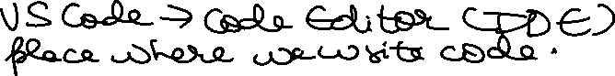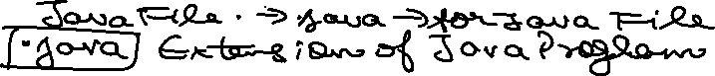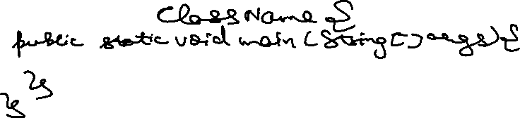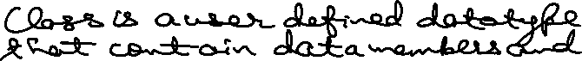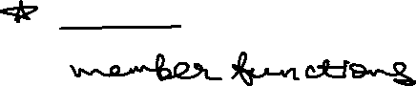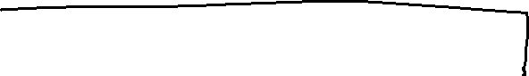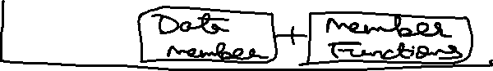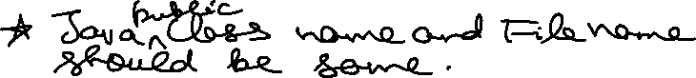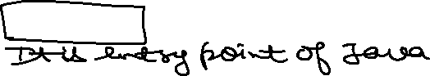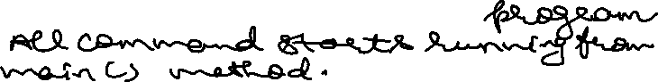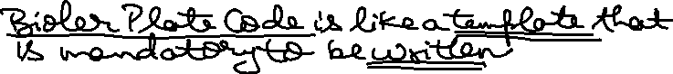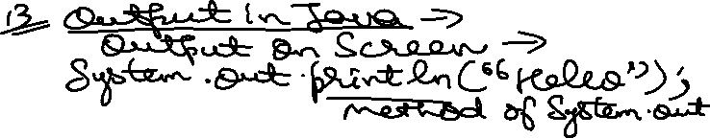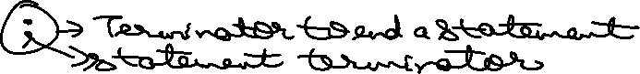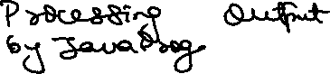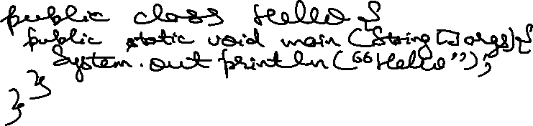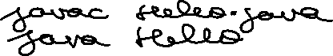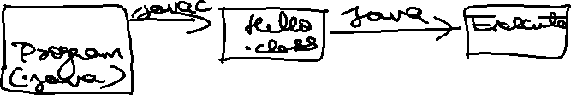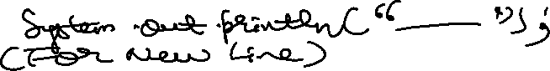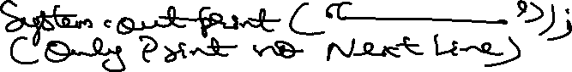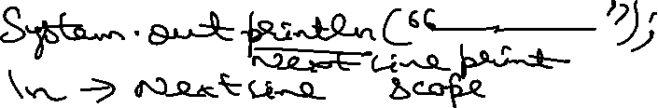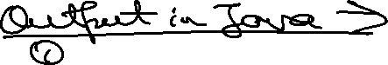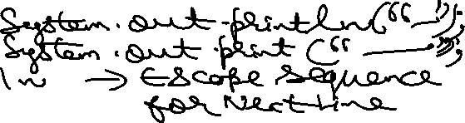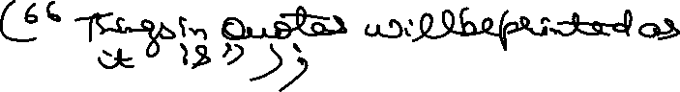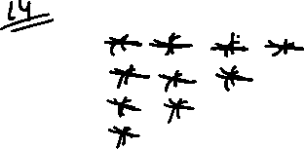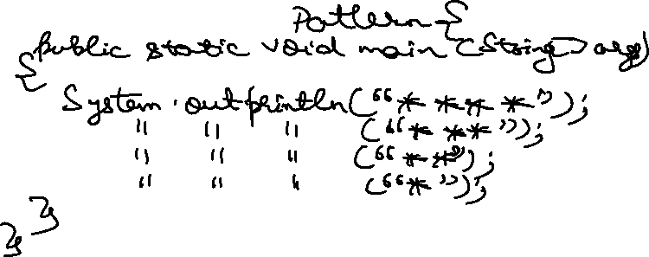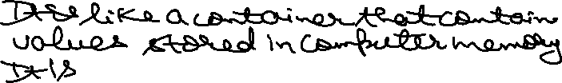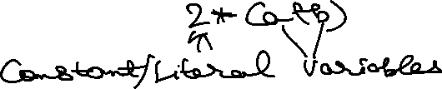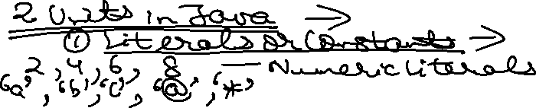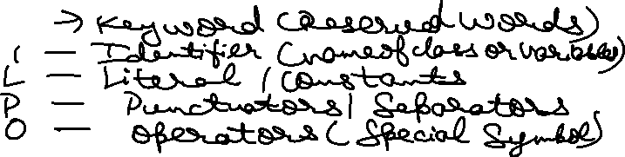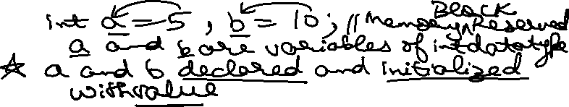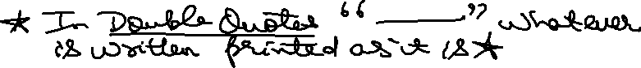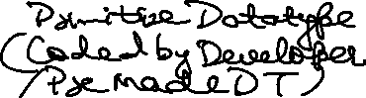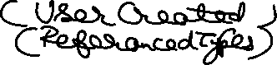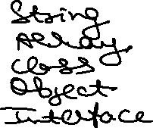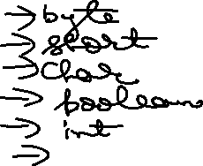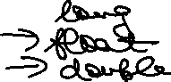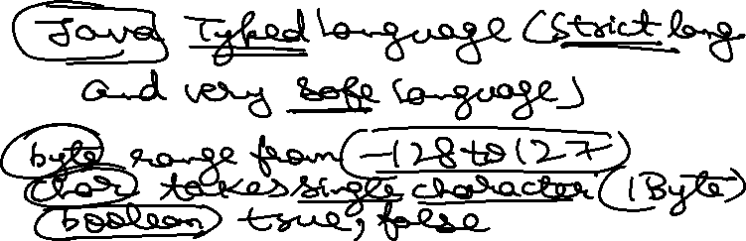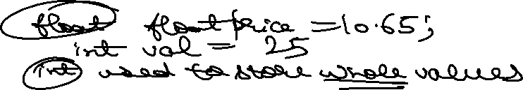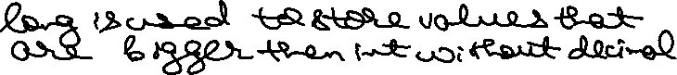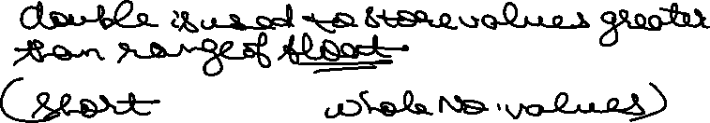

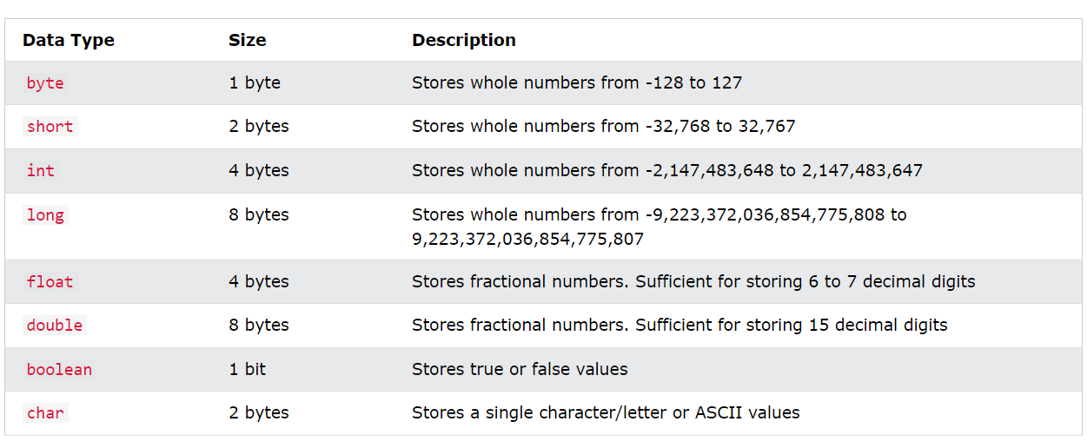

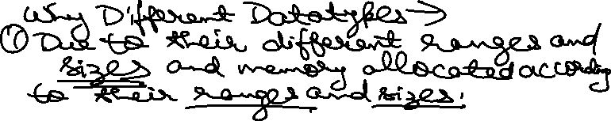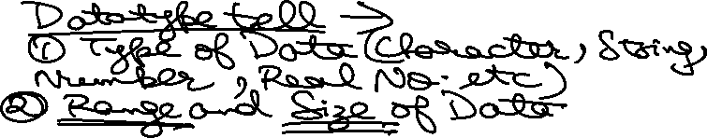

public class SumofAB {

    public static void main(String[] args) {

        int a = 10;

        int b = 20;

        System.out.println("Addition of Two Numbers = "+(a+b));

    }

}

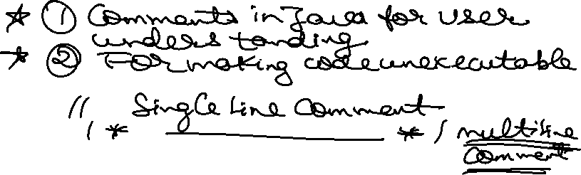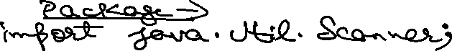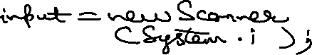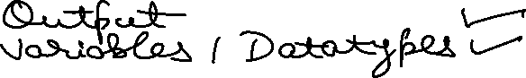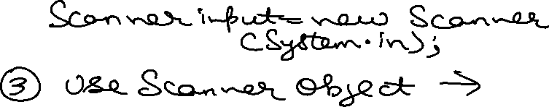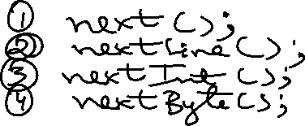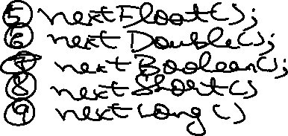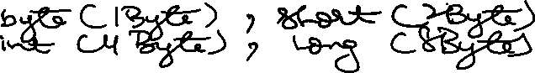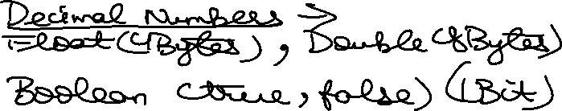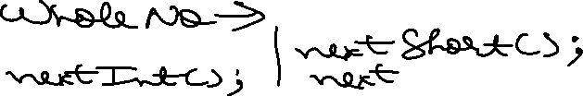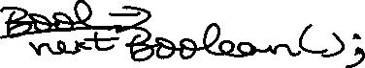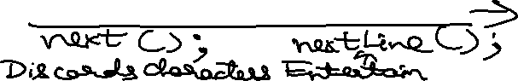

import java.util.Scanner;

public class SumofABInput {

    public static void main(String[] args) {

        int num1, num2, sum;

        System.out.println("Enter the Value of Two Numbers = ");

        Scanner input = new Scanner(System.in);

        // input

        System.out.print("Enter the Value of Number 1 = ");

        num1 = input.nextInt();

        System.out.print("Enter the Value of Number 2 = ");

        num2 = input.nextInt();

        // sum

        sum = num1 + num2;

        System.out.println("Sum of Two Numbers = "+sum);

        // input close

        input.close();

    }

}

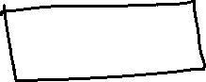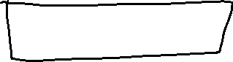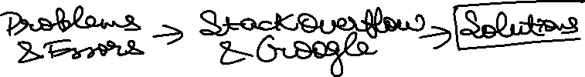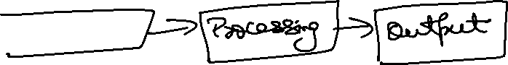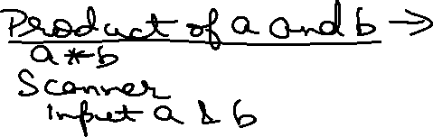

import java.util.Scanner;

class Product {

    public static void main(String[] args) {

        int num1, num2, product;

        System.out.println("Enter the Value of Two Numbers = ");

        Scanner input = new Scanner(System.in);

        // input

        System.out.print("Enter the Value of Number 1 = ");

        num1 = input.nextInt();

        System.out.print("Enter the Value of Number 2 = ");

        num2 = input.nextInt();

        // sum

        product = num1 \* num2;

        System.out.println("Product of Two Numbers = "+product);

        // input close

        input.close();

    }

}

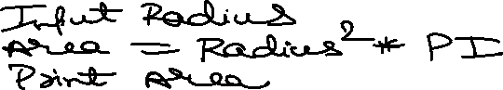

import java.util.\*;

class AreaofCircle {

    public static void main(String[] args) {

        Scanner input = new Scanner(System.in);

        System.out.println("Enter Radius of Circle = ");

        double radius = input.nextFloat();

        double Area = Math.PI \* Math.pow(radius, 2);

        System.out.println("Pi is = "+Math.PI);

        System.out.println("Area of Circle is = "+Area);

        input.close();

    }

}

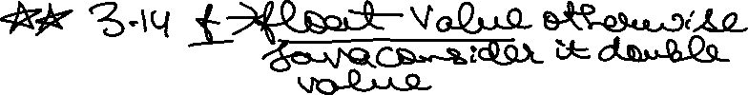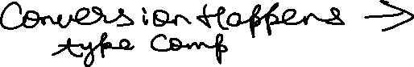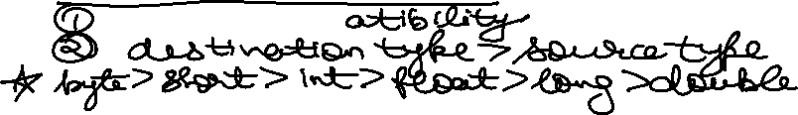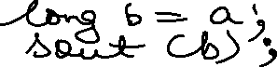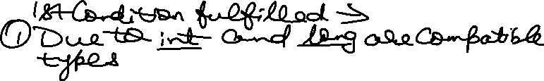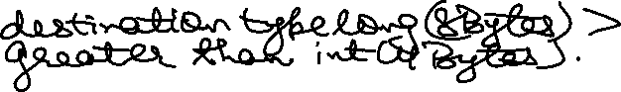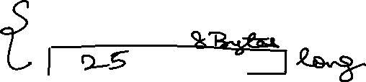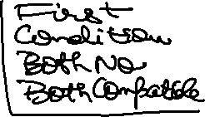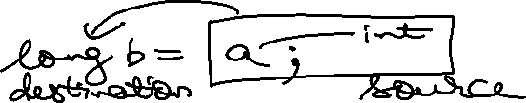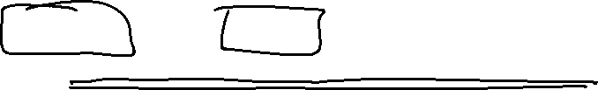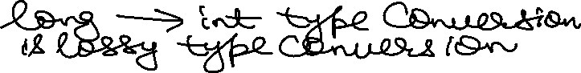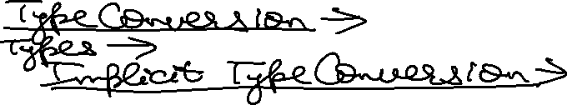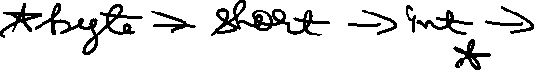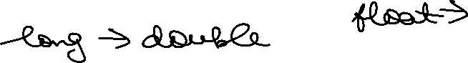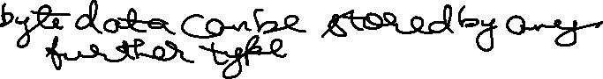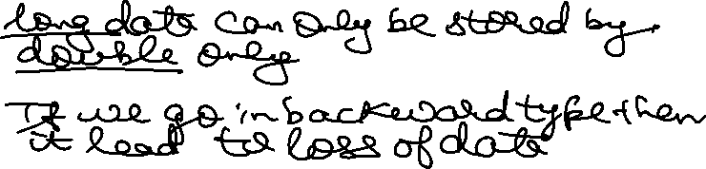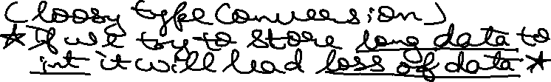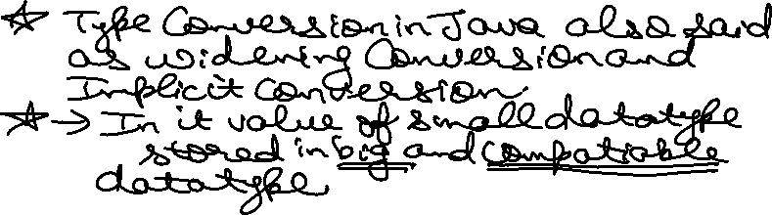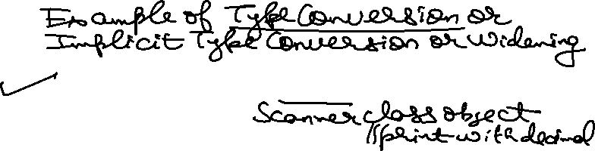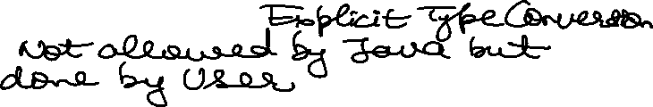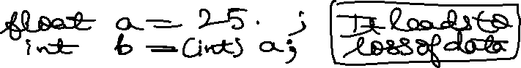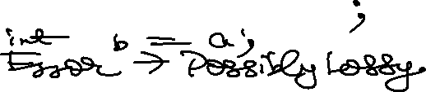

import java.util.Scanner;

class TypeConversion {

    public static void main(String[] args) {

        Scanner input = new Scanner(System.in);

        System.out.print("Enter the Value of Number = ");

        float n1 = input.nextInt();

        // allowed in java, int -> float implicit type conversion

        System.out.println("Number is = "+n1);

        input.close();

    }

}

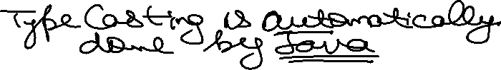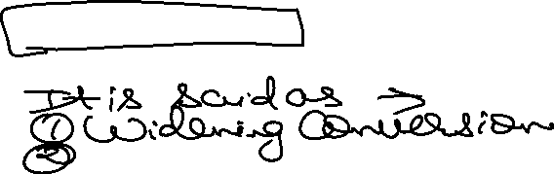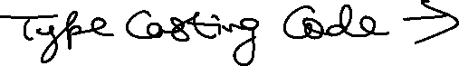

import java.util.Scanner;

class TypeCasting {

    public static void main(String[] args) {

        Scanner input = new Scanner(System.in);

        System.out.print("Enter the Value of Double Number = ");

        double d1 = input.nextDouble();

        int i1 = (int) d1;

        System.out.println("Double to int Type Casting is = "+i1);

        input.close();

    }

}

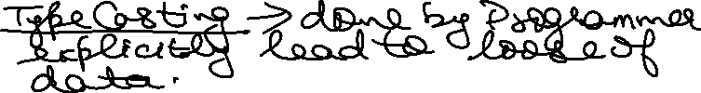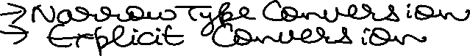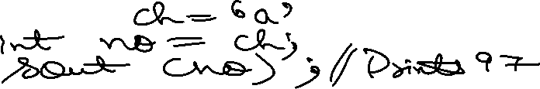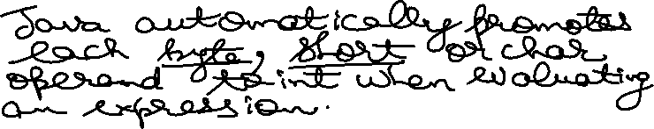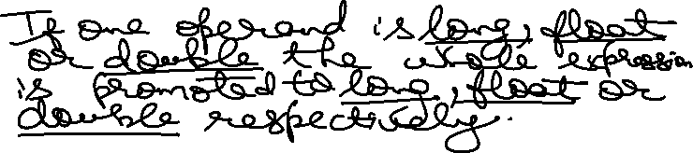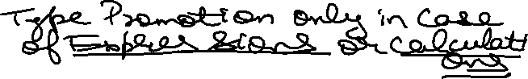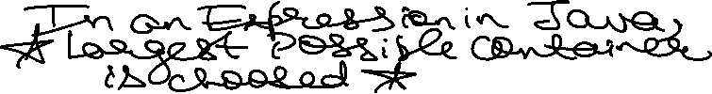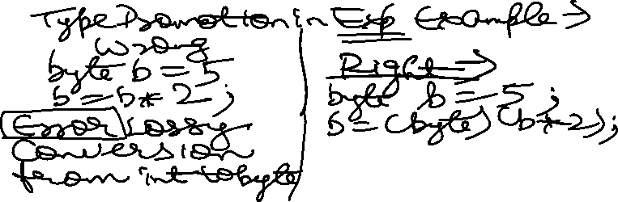

class TypePromotion {

    public static void main(String[] args) {

        char a = 'a';

        char b = 'b';

        System.out.println("a+b is "+(a+b));

        System.out.println("b-a is "+(b-a));

        // char c = a - b Error converting from char to int and storing in char

        short s = 5;

        byte b1 = 25;

        char A = 'A';

        // byte bt = s + b1 + A; Error because possible lossy conversions from int to byte

        byte bt = (byte)(s + b1 + A); //using type casting everything possible

        System.out.println(bt); // 5 + 25 + A(65) = 95

        // 2nd principle ->

        int int1 = 40;

        float flo1 = 128.193028f;

        long long1 = 9123;

        double double1 = 12908.123890;

        // int resulttest = int1 + flo1 + long1 + double1; error lossy conversion from double to int

        double result = int1 + flo1 + long1 + double1;

        System.out.println(result);

    }

}

